Statistical Analysis Report
The Effect of Credibility of AI-Generated Business Content on Communication Strategies Among Coffee Shop Owners and Managers in CAMANAVA
Computed by
Engr. Jamie Eduardo Rosal, MSCpE
May 2026

Abstract / Executive Statistical Summary
This report presents a quantitative statistical analysis of 60 valid survey responses from the available AITHOS survey workbook. The analysis is aligned with the research problem stated in the final research manuscript and the structured instrument on AI-generated business content credibility, algorithmic transparency, technology acceptance, and communication strategies. Because the provided workbook contains Parts II to V only, Part I business profile statistics are not computed and no profile data are inferred.
The respondents generally evaluated AI-generated business content favorably. Overall AI credibility obtained a mean of 3.074 (Agree / High), while overall communication strategy obtained a mean of 3.250 (Agree / High). The primary inferential result showed a Moderate positive relationship between overall credibility and overall communication strategy, r = 0.638, p = < .001, indicating that the relationship is significant at alpha = 0.05.

Methodology

Dataset and Scope
The official source dataset is AITHOS-SURVEY-RAW-DATA.xlsx. The workbook contains four usable sheets: Part II for credibility, Part III for algorithmic transparency, Part IV for technology acceptance, and Part V for communication strategies. The dataset contains 60 aligned respondent records across all available construct sheets.
The final research manuscript also calls for a respondent business profile analysis, but the available workbook does not include the Part I profile variables. Accordingly, this report omits the business profile tables and limits the computations to the available Likert-scale data. This limitation protects the integrity of the analysis by avoiding invented or unverified profile values.

Instrument and Scoring Procedure
The survey instrument uses a four-point Likert scale: 4 = Strongly Agree, 3 = Agree, 2 = Disagree, and 1 = Strongly Disagree. Item means were interpreted as follows: 3.26-4.00 = Strongly Agree / Very High, 2.51-3.25 = Agree / High, 1.76-2.50 = Disagree / Low, and 1.00-1.75 = Strongly Disagree / Very Low.
For each construct, respondent-level scores were computed as the arithmetic mean of the five item responses under that construct. Overall AI Credibility was computed from Expertise and Trustworthiness. Overall Communication Strategy was computed from Quality of Content, Message Consistency, and Audience Engagement. Technology Acceptance scores were summarized descriptively as supplemental context.

Statistical Treatments
The analysis used descriptive statistics, Cronbach's alpha reliability coefficients, and Pearson product-moment correlations. Pearson correlation was selected as the primary inferential treatment because the research question asks whether AI credibility is significantly related to communication strategies. Statistical significance was evaluated at alpha = 0.05.

Data Validation Summary
Respondent count: 60
Respondent IDs aligned: 1 to 60
Out-of-range Likert values: 0
Missing Likert values: 1
Expertise: 5 items, 60 respondents
Trustworthiness: 5 items, 60 respondents
Algorithmic Transparency: 5 items, 60 respondents
Perceived Usefulness: 5 items, 60 respondents
Perceived Ease of Use: 5 items, 60 respondents
Quality of Content: 5 items, 60 respondents
Message Consistency: 5 items, 60 respondents
Audience Engagement: 5 items, 60 respondents

Results

Descriptive Statistics by Construct
Table 1. Construct-Level Descriptive Statistics
Construct | Mean | SD | Min | Max | Interpretation
Expertise | 3.068 | 0.451 | 2.400 | 3.800 | Agree / High
Trustworthiness | 3.080 | 0.508 | 2.000 | 3.800 | Agree / High
Overall Credibility | 3.074 | 0.450 | 2.400 | 3.800 | Agree / High
Algorithmic Transparency | 3.170 | 0.466 | 2.400 | 4.000 | Agree / High
Perceived Usefulness | 3.130 | 0.515 | 2.400 | 4.000 | Agree / High
Perceived Ease of Use | 3.387 | 0.321 | 2.200 | 4.000 | Strongly Agree / Very High
Overall Technology Acceptance | 3.258 | 0.344 | 2.400 | 3.900 | Agree / High
Quality of Content | 3.097 | 0.461 | 2.400 | 4.000 | Agree / High
Message Consistency | 3.277 | 0.336 | 2.600 | 4.000 | Strongly Agree / Very High
Audience Engagement | 3.377 | 0.321 | 2.800 | 4.000 | Strongly Agree / Very High
Overall Communication Strategy | 3.250 | 0.278 | 2.733 | 3.933 | Agree / High

The construct-level descriptive statistics show that the available respondent ratings cluster in the Agree to Strongly Agree range. This suggests that AI-generated business content is generally viewed as credible and useful by the sampled coffee shop owners and managers, while communication strategy ratings also indicate favorable perceived performance.

Item-Level Weighted Means
Table. Expertise Items
Item | Statement | Mean | SD | Interpretation
1 | AI provides accurate information regarding coffee shop trends. | 3.117 | 0.666 | Agree / High
2 | AI-generated content demonstrates a high level of knowledge about the industry. | 3.150 | 0.685 | Agree / High
3 | The suggestions made by the AI appear professional. | 2.933 | 0.710 | Agree / High
4 | AI-generated suggestions are realistic for business applications. | 3.017 | 0.651 | Agree / High
5 | The AI quickly provides relevant solutions for coffee shop promotion. | 3.136 | 0.706 | Agree / High

Table. Trustworthiness Items
Item | Statement | Mean | SD | Interpretation
1 | AI-generated content is perceived as trustworthy. | 3.183 | 0.701 | Agree / High
2 | AI-generated content can provide unbiased marketing suggestions. | 2.983 | 0.651 | Agree / High
3 | AI-generated content aligns with the brand's values. | 3.017 | 0.725 | Agree / High
4 | AI-generated content can be trusted for customer communication. | 3.133 | 0.700 | Agree / High
5 | AI-generated content provides dependable communication support. | 3.083 | 0.671 | Agree / High

Table. Algorithmic Transparency Items
Item | Statement | Mean | SD | Interpretation
1 | It is clear how the AI decides what content to generate. | 3.150 | 0.685 | Agree / High
2 | The respondent understands why AI produces specific results from prompts. | 3.167 | 0.615 | Agree / High
3 | The way the AI functions is not unfamiliar. | 3.150 | 0.709 | Agree / High
4 | The way AI creates suggestions is easy to follow. | 3.167 | 0.717 | Agree / High
5 | The respondent knows the limitations and weak spots of the AI tool used. | 3.217 | 0.613 | Agree / High

Table. Perceived Usefulness Items
Item | Statement | Mean | SD | Interpretation
1 | Using AI enhances productivity in managing the coffee shop. | 3.150 | 0.606 | Agree / High
2 | AI tools help reach marketing goals more effectively. | 3.150 | 0.659 | Agree / High
3 | AI tools are useful in daily business operations. | 3.083 | 0.720 | Agree / High
4 | AI tools assist in identifying new business opportunities. | 3.050 | 0.746 | Agree / High
5 | Relying on AI helps handle unexpected business challenges more effectively. | 3.217 | 0.640 | Agree / High

Table. Perceived Ease of Use Items
Item | Statement | Mean | SD | Interpretation
1 | Interacting with AI tools does not require much mental effort. | 3.450 | 0.502 | Strongly Agree / Very High
2 | It is easy to get AI to do what the respondent wants it to do. | 3.467 | 0.536 | Strongly Agree / Very High
3 | Learning to operate AI tools is easy. | 3.317 | 0.676 | Strongly Agree / Very High
4 | AI tools can be accessed without complicated setup. | 3.400 | 0.643 | Strongly Agree / Very High
5 | The respondent does not need help to figure out how to use AI tools properly. | 3.300 | 0.696 | Strongly Agree / Very High

Table. Quality of Content Items
Item | Statement | Mean | SD | Interpretation
1 | AI-generated content is clear to understand and relevant. | 3.083 | 0.591 | Agree / High
2 | AI-generated content meets quality standards before posting. | 3.133 | 0.650 | Agree / High
3 | AI-generated content provides reliable information to customers. | 3.017 | 0.701 | Agree / High
4 | AI organizes text so online readers can scan it easily. | 3.033 | 0.712 | Agree / High
5 | AI quickly gives content that fits current trends or seasons. | 3.217 | 0.524 | Agree / High

Table. Message Consistency Items
Item | Statement | Mean | SD | Interpretation
1 | AI-assisted messages align with business values. | 3.300 | 0.530 | Strongly Agree / Very High
2 | Customer communication remains consistent when using AI. | 3.317 | 0.651 | Strongly Agree / Very High
3 | AI helps deliver messages across different platforms. | 3.283 | 0.640 | Strongly Agree / Very High
4 | Customers are not confused by information AI helps write. | 3.183 | 0.701 | Agree / High
5 | AI content sounds like it was written by a real staff member. | 3.300 | 0.696 | Strongly Agree / Very High

Table. Audience Engagement Items
Item | Statement | Mean | SD | Interpretation
1 | AI helps increase customer engagement. | 3.400 | 0.588 | Strongly Agree / Very High
2 | AI helps respond quickly to customer inquiries. | 3.467 | 0.596 | Strongly Agree / Very High
3 | AI encourages customer feedback and interaction. | 3.283 | 0.691 | Strongly Agree / Very High
4 | AI-written captions or promos make customers want to visit or buy. | 3.333 | 0.655 | Strongly Agree / Very High
5 | AI writes captions using language and trends local coffee lovers understand. | 3.400 | 0.616 | Strongly Agree / Very High

Visual Analysis of Findings
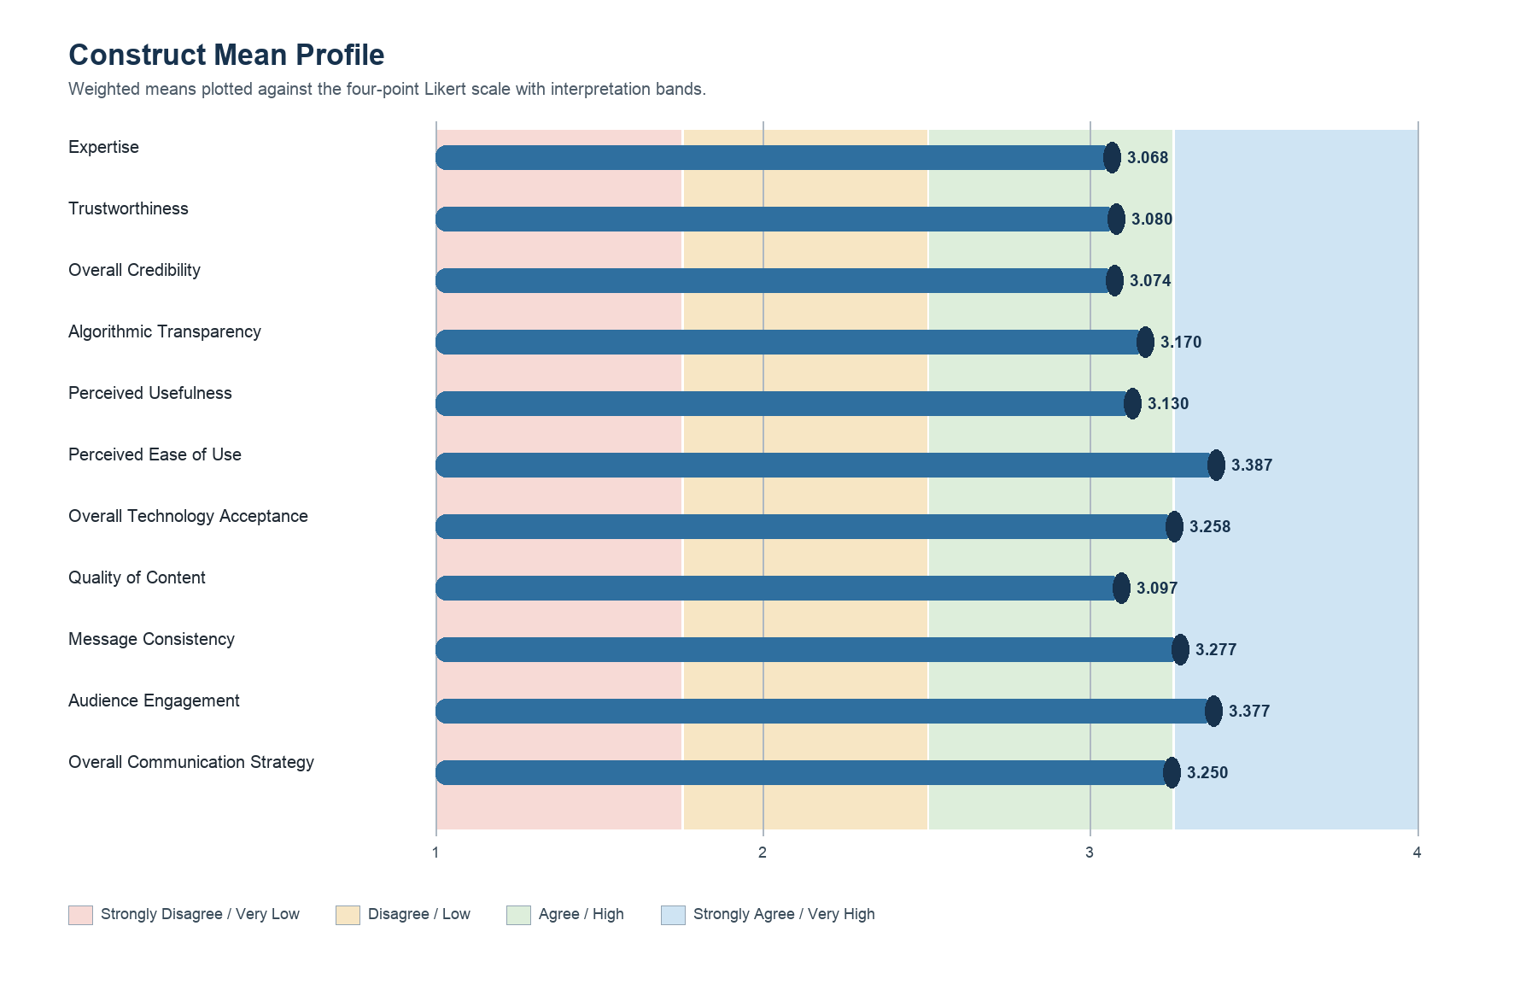
Figure 1. Construct mean profile plotted against the four-point Likert scale.
Figure 1 shows that the construct means generally fall within the Agree / High and Strongly Agree / Very High interpretation ranges. This visual profile supports the descriptive conclusion that the respondents evaluated AI credibility, technology acceptance, and AI-supported communication strategies favorably, while still preserving differences between constructs.
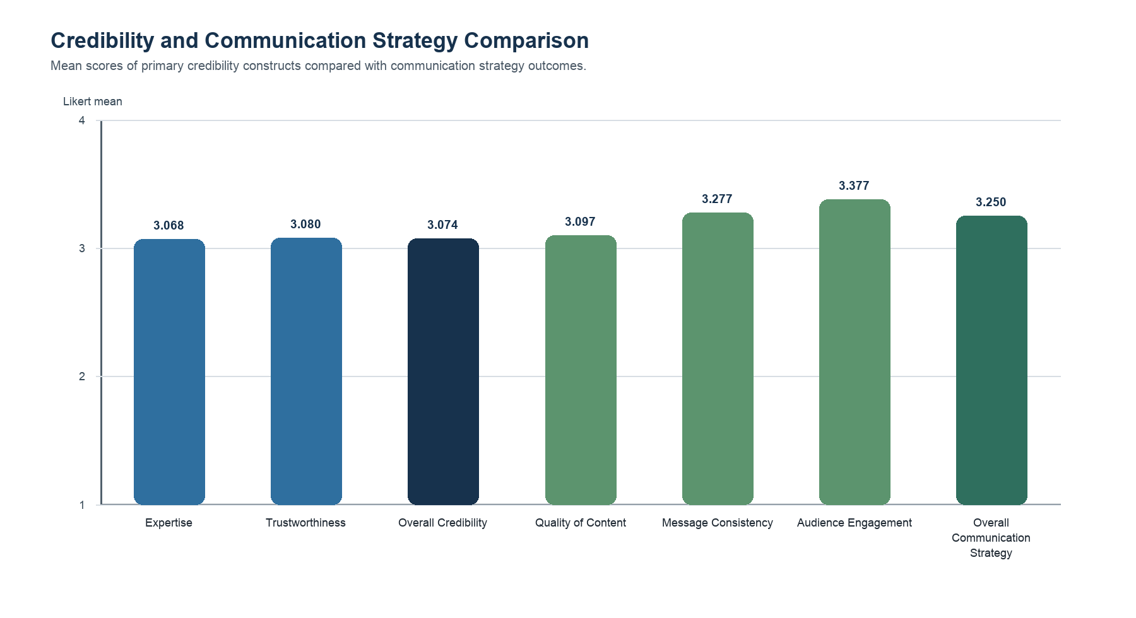
Figure 2. Mean comparison of AI credibility and communication strategy constructs.
Figure 2 places the primary independent and dependent constructs side by side. The communication strategy subscales, particularly message consistency and audience engagement, are positioned near or above the Strongly Agree threshold, while credibility indicators remain within the Agree / High range.
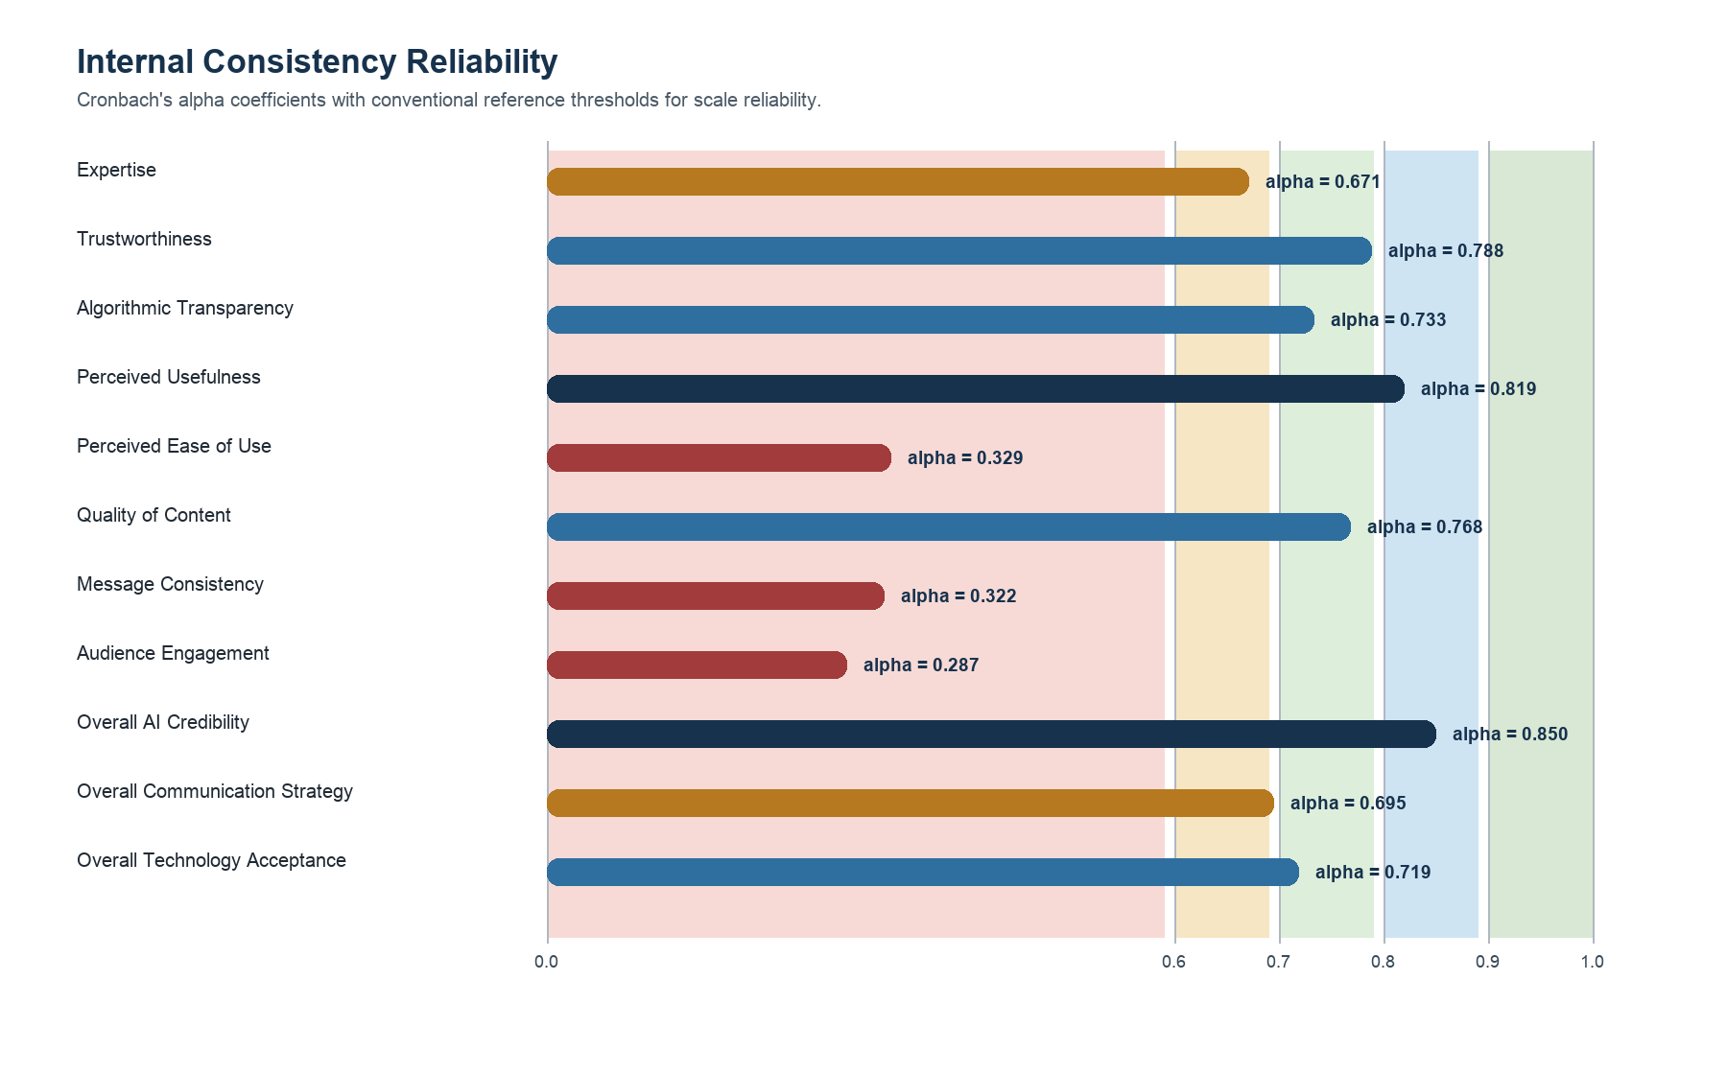
Figure 3. Cronbach's alpha reliability coefficients by scale.
Figure 3 highlights the internal consistency of the instrument scales. Overall AI Credibility shows good reliability, several individual scales are acceptable, and lower alpha values are made visible so readers can interpret specific subscales with appropriate caution.
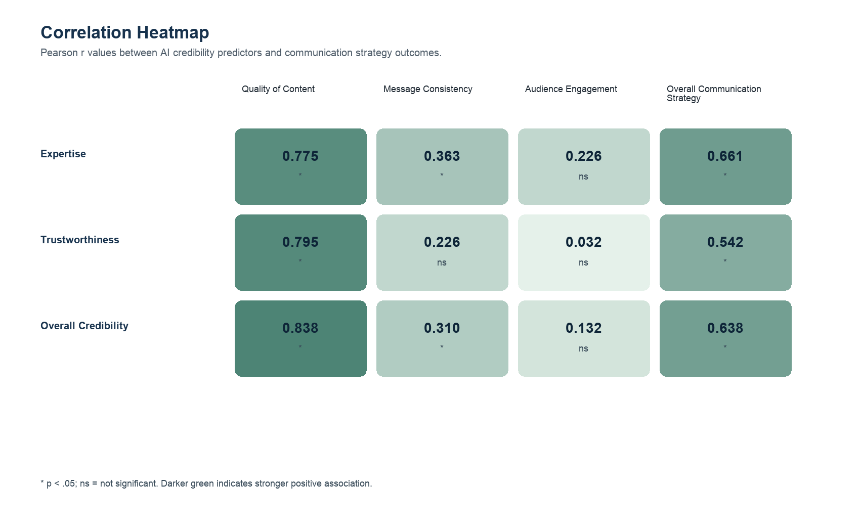
Figure 4. Heatmap of Pearson correlations between credibility predictors and strategy outcomes.
Figure 4 makes the inferential pattern easier to inspect: credibility is most strongly associated with quality of content, while audience engagement shows weaker and non-significant relationships. This distinction is useful because it shows that credibility does not affect every communication outcome with the same magnitude.
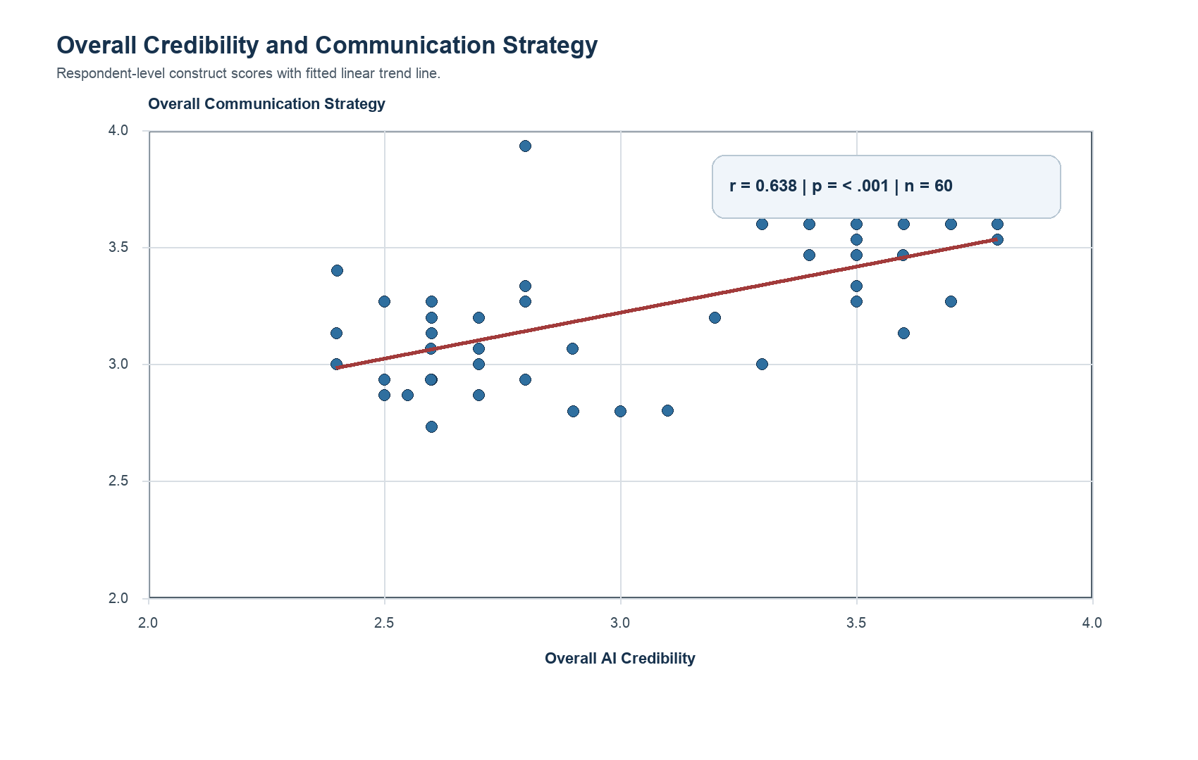
Figure 5. Respondent-level relationship between overall credibility and overall communication strategy.
Figure 5 provides a respondent-level view of the primary test. The upward trend line and the annotated coefficient show a significant moderate positive relationship, indicating that higher perceived AI credibility tends to accompany stronger overall communication strategy ratings.

Reliability Analysis
Table 2. Internal Consistency Reliability
Scale | Items | Cronbach Alpha | Interpretation
Expertise | 5 | 0.671 | Questionable
Trustworthiness | 5 | 0.788 | Acceptable
Algorithmic Transparency | 5 | 0.733 | Acceptable
Perceived Usefulness | 5 | 0.819 | Good
Perceived Ease of Use | 5 | 0.329 | Low
Quality of Content | 5 | 0.768 | Acceptable
Message Consistency | 5 | 0.322 | Low
Audience Engagement | 5 | 0.287 | Low
Overall AI Credibility | 10 | 0.850 | Good
Overall Communication Strategy | 15 | 0.695 | Questionable
Overall Technology Acceptance | 10 | 0.719 | Acceptable

Cronbach's alpha was used to evaluate whether the items within each multi-item scale consistently measure the same latent construct. Higher alpha coefficients indicate stronger internal consistency, while lower values should be interpreted as evidence that items may be measuring a more heterogeneous set of perceptions.

Correlation Analysis
Table 3. Pearson Correlations Between AI Credibility and Communication Strategies
Predictor | Outcome | n | r | p-value | Decision | Interpretation
Expertise | Quality of Content | 60 | 0.775 | < .001 | Significant | Strong positive
Expertise | Message Consistency | 60 | 0.363 | 0.004 | Significant | Weak positive
Expertise | Audience Engagement | 60 | 0.226 | 0.082 | Not significant | Very weak positive
Expertise | Overall Communication Strategy | 60 | 0.661 | < .001 | Significant | Moderate positive
Trustworthiness | Quality of Content | 60 | 0.795 | < .001 | Significant | Strong positive
Trustworthiness | Message Consistency | 60 | 0.226 | 0.083 | Not significant | Very weak positive
Trustworthiness | Audience Engagement | 60 | 0.032 | 0.807 | Not significant | Negligible positive
Trustworthiness | Overall Communication Strategy | 60 | 0.542 | < .001 | Significant | Moderate positive
Overall Credibility | Quality of Content | 60 | 0.838 | < .001 | Significant | Strong positive
Overall Credibility | Message Consistency | 60 | 0.310 | 0.016 | Significant | Weak positive
Overall Credibility | Audience Engagement | 60 | 0.132 | 0.316 | Not significant | Very weak positive
Overall Credibility | Overall Communication Strategy | 60 | 0.638 | < .001 | Significant | Moderate positive

The primary test addresses whether AI credibility is significantly associated with communication strategies among CAMANAVA coffee shop owners and managers. The correlation table should be read by examining the sign, magnitude, and significance of r. Positive coefficients indicate that higher credibility ratings tend to move with stronger communication strategy ratings.

Discussion
The findings support the conceptual logic of Source Credibility Theory in the AI-generated business content context. When AI content is perceived as knowledgeable, professional, dependable, and aligned with brand communication needs, coffee shop owners and managers also tend to evaluate their AI-assisted communication strategies more favorably. This is theoretically consistent with the proposition that credibility strengthens persuasion and acceptance of communication sources.
Algorithmic transparency and TAM3 variables were treated as descriptive supplemental constructs in this report. Their inclusion remains important because transparency, usefulness, and ease of use provide context for why business users may accept or reject AI-generated content in daily marketing communication. However, the primary inferential emphasis remains the relationship between AI credibility and communication strategies, as specified in the approved analysis plan.
For CAMANAVA coffee shops, the results imply that AI adoption should not be evaluated merely by speed or automation convenience. Owners and managers should also examine whether AI-generated messages remain accurate, trustworthy, brand-consistent, locally understandable, and capable of supporting customer engagement without weakening perceived authenticity.

Conclusion and Recommendations
Based on the available survey data, AI-generated business content credibility is positively associated with communication strategy outcomes. This indicates that strengthening the perceived expertise and trustworthiness of AI-generated content may contribute to better content quality, stronger message consistency, and improved audience engagement.
- Coffee shop owners and managers should review AI-generated content before publication to preserve accuracy, warmth, and brand voice.
- AI tools should be used as communication support systems rather than full replacements for human judgment.
- Businesses should document prompt practices, review standards, and content approval workflows to improve credibility and transparency.
- Future research should collect and analyze Part I profile variables to test whether business size, AI usage duration, and frequency of use shape credibility perceptions.

Appendix A: Construct Mapping
Construct | Domain | Source Sheet | Items
Expertise | AI Credibility | PART II. | 5
Trustworthiness | AI Credibility | PART II. | 5
Algorithmic Transparency | Algorithmic Transparency | PART III. | 5
Perceived Usefulness | Technology Acceptance | PART IV. | 5
Perceived Ease of Use | Technology Acceptance | PART IV. | 5
Quality of Content | Communication Strategies | PART V. | 5
Message Consistency | Communication Strategies | PART V. | 5
Audience Engagement | Communication Strategies | PART V. | 5

Appendix B: Validation Notebook
The reproducible computation file is AITHOS_Statistical_Computations_Validation.ipynb. It loads the raw workbook, reconstructs the construct mapping, validates the Likert response range and respondent alignment, and recomputes all descriptive, reliability, and correlation tables used in this report.

